JAVA SCRIPT PART 3 :

Synchronous programming lang vs asynchronous programming lang :

Note : JavaScript is single thread synchronous programming lang .

Set timeout function : it will going to take function and time in milli second as input and specify the minimum time after which that function will going to run .

Note : set time out is browser functionality it will going to run by browser

ii ) function inside the set time out execute only after the whole js code execute and it will be executed by browser not by js .

iii) function inside the set time out will after its compliation of its time it will going to store in callback queue .

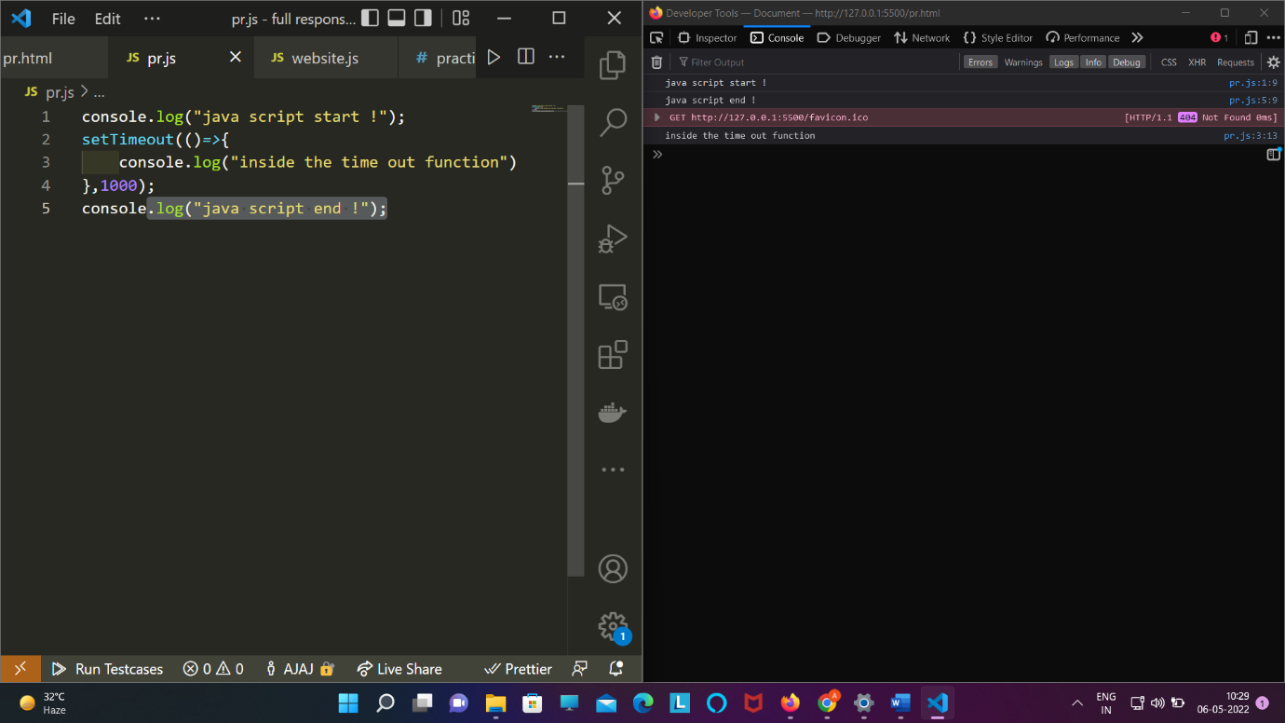

iv) 1000msecond = 1second

v ) if we try to store set time out in a variable the it will going to store as 1 ,2 ,3 …….

Eg : const var1=settimeout(function(),1000);

Console.log(var1) // output 1 ;

Clear time out : this will going to take input as a variable which we store set time out and it forced the set time out not to run;

console.log("java script start !");

*const* id=setTimeout(()*=>*{

    console.log("inside the time out function")

},0);

console.log("java script end !");

clearTimeout(id);

Application of set time out and function callback :

We want to change text content and color at ever second :

Html :

<!DOCTYPE html>

<html lang="en">

<head>

    <meta charset="UTF-8">

    <meta http-equiv="X-UA-Compatible" content="IE=edge">

    <meta name="viewport" content="width=device-width, initial-scale=1.0">

    <title>Document</title>

    <script src="pr.js" defer></script>

    <style>

        div{

*position*: absolute;

*top*: 50%;

*left*: 50%;

*transform*: translate(-50%,-50%);

        }

    </style>

</head>

<body>

    <div>

        <h1 class="h1">heading1</h1>

        <h1 class="h2">heading2</h1>

        <h1 class="h3">heading3</h1>

        <h1 class="h4">heading4</h1>

        <h1 class="h5">heading5</h1>

        <h1 class="h6">heading6</h1>

    </div>

</body>

</html>

Js :

setTimeout(() *=>* {

*const* h1 = document.querySelector(".h1");

  h1.textContent = "one";

  h1.style.color = "violet";

  setTimeout(() *=>* {

*const* h2 = document.querySelector(".h2");

    h2.textContent = "two";

    h2.style.color = "purple";

    setTimeout(() *=>* {

*const* h3 = document.querySelector(".h3");

      h3.textContent = "three";

      h3.style.color = "red";

      setTimeout(() *=>* {

*const* h4 = document.querySelector(".h4");

        h4.textContent = "four";

        h4.style.color = "pink";

        setTimeout(() *=>* {

*const* h5 = document.querySelector(".h5");

          h5.textContent = "five";

          h5.style.color = "green";

          setTimeout(()*=>*{

*const* h6=document.querySelector(".h6");

                h6.textContent="six";

                h6.style.color="blue";

            },1000)

        }, 1000);

      }, 1000);

    }, 1000);

  }, 1000);

}, 1000);